Nama : Muhammad Rafi Rizqullah

NIM : 09011282126091

Kelas : SK6C

Tugas Sistem Terdistribusi

1. [www.1cak.com](http://www.1cak.com)
2. nslookup

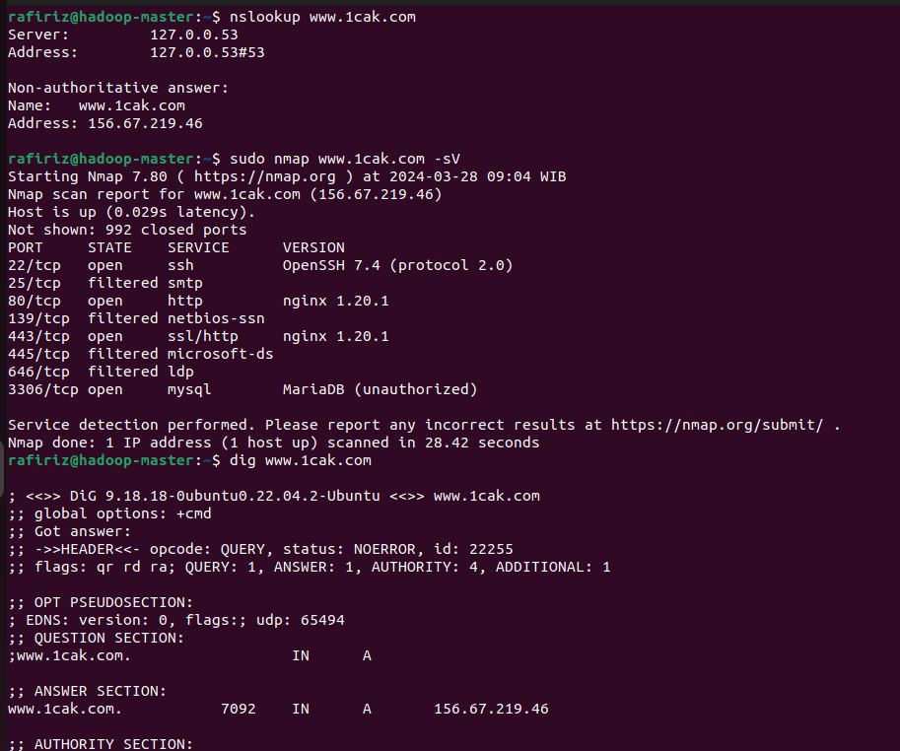

1. nmap



1. dig

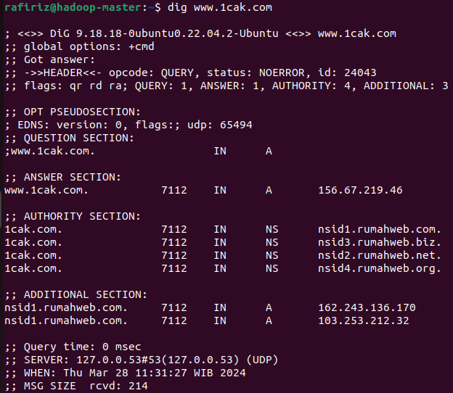

1. [www.9gag.com](http://www.9gag.com)
2. nslookup

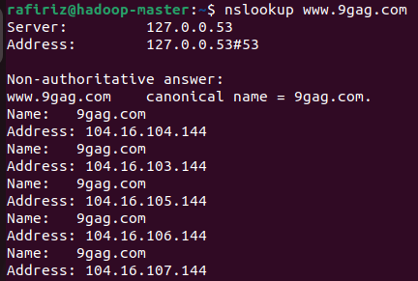

1. nmap

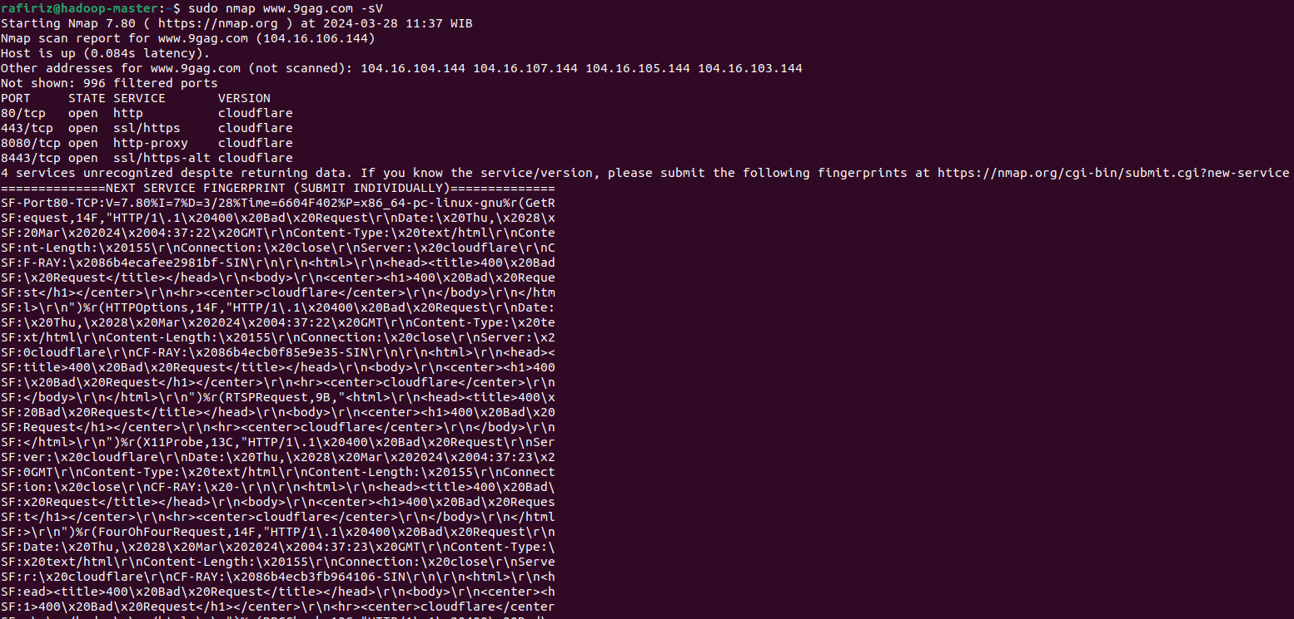

1. dig

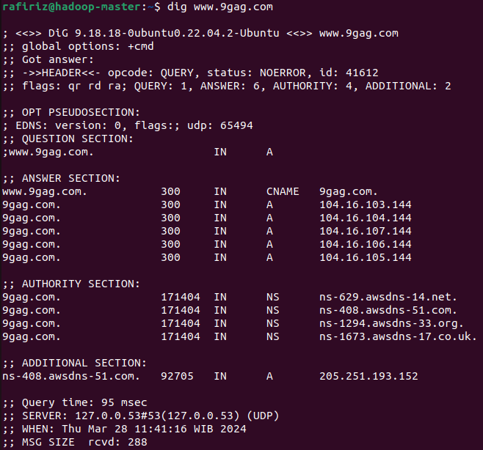

1. [www.twitter.com](http://www.twitter.com)
2. nslookup

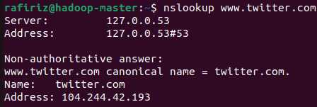

1. nmap

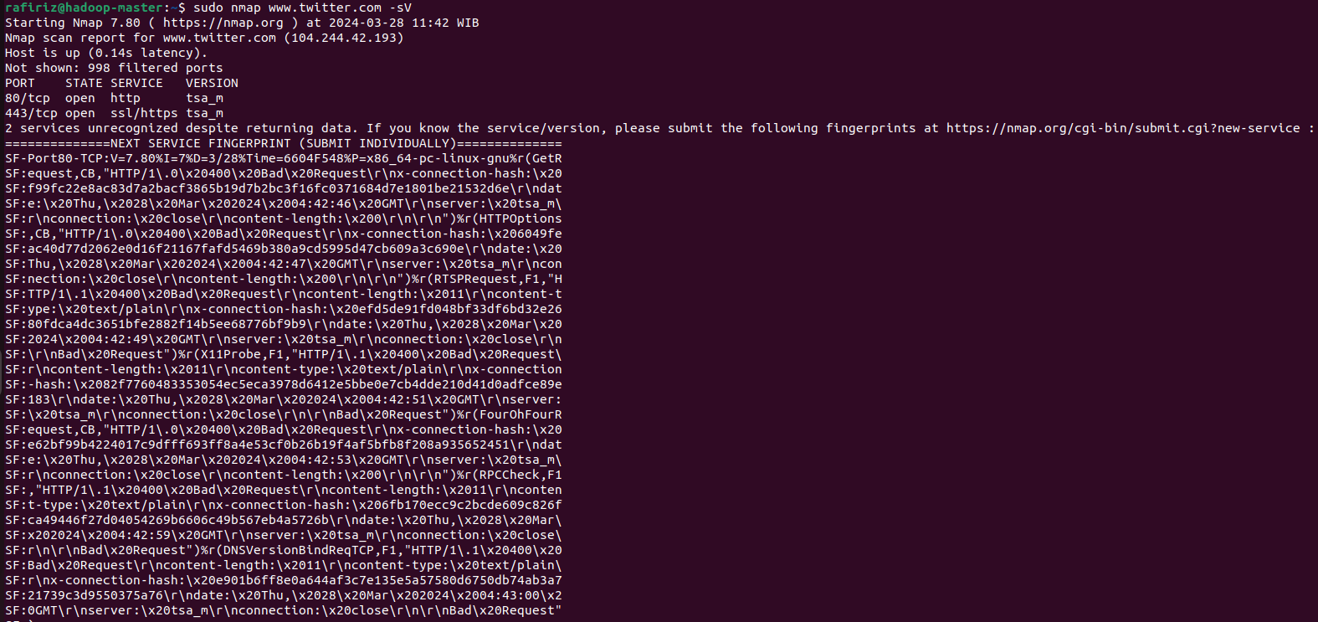

1. dig

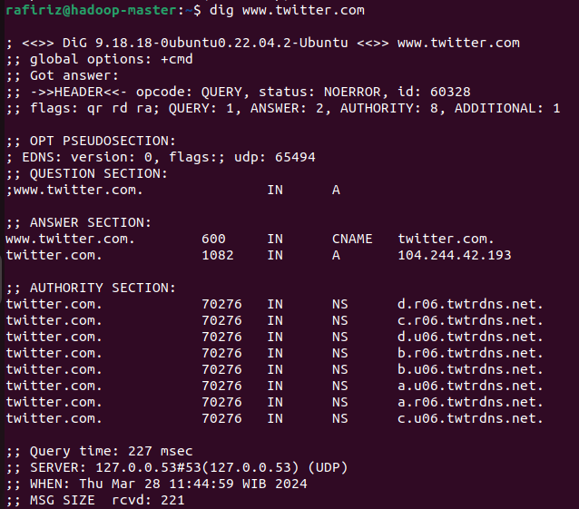

1. [www.spotify.com](http://www.spotify.com)
2. nslookup

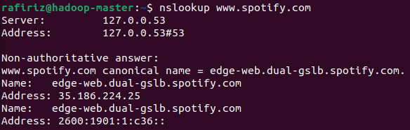

1. nmap

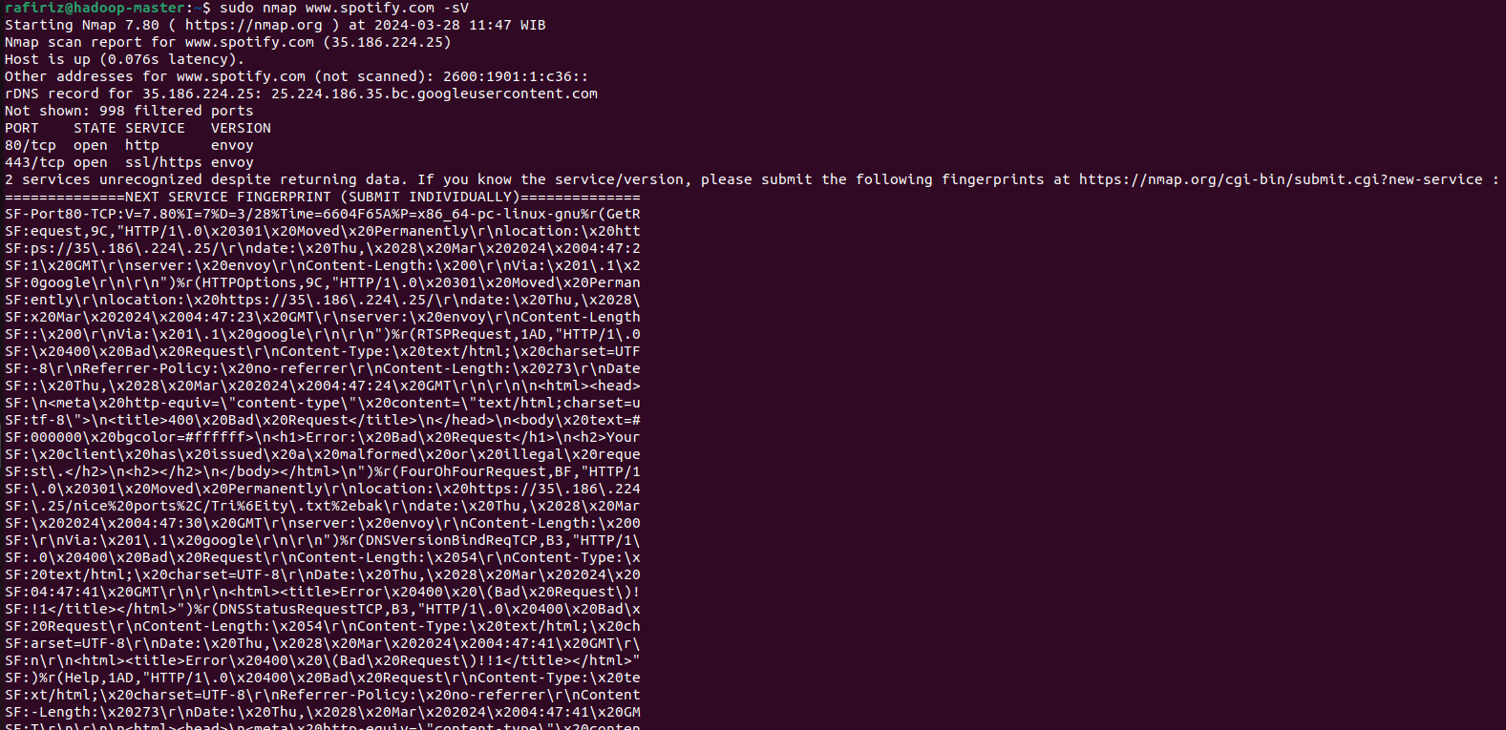

1. dig

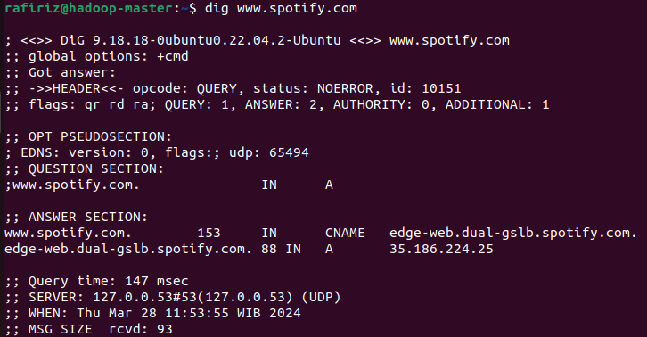

1. [www.youtube.com](http://www.youtube.com)
2. nslookup

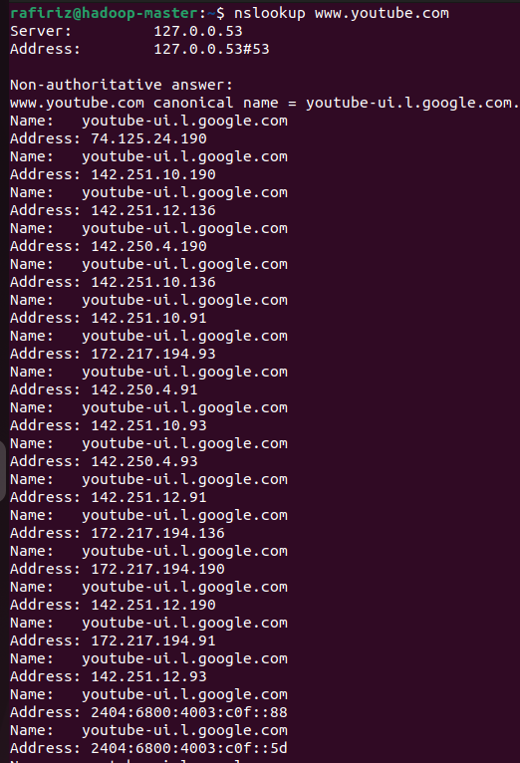

1. nmap

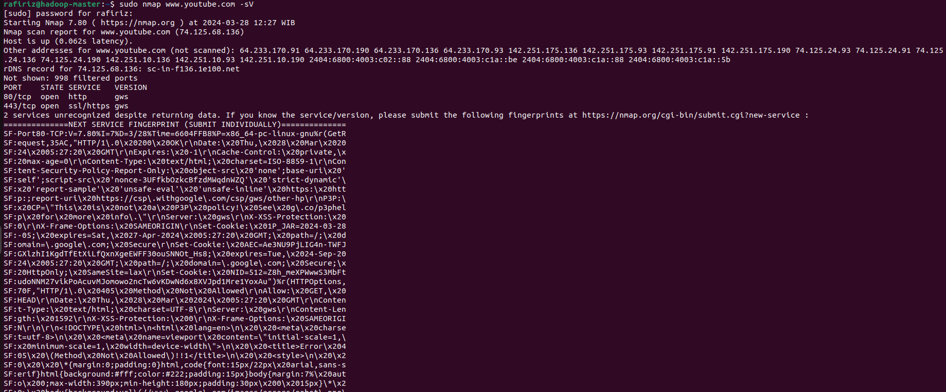

1. dig

